1. MongoDB shell is based on JavaScript Engine. It support ECMAScript Syntax.
2. 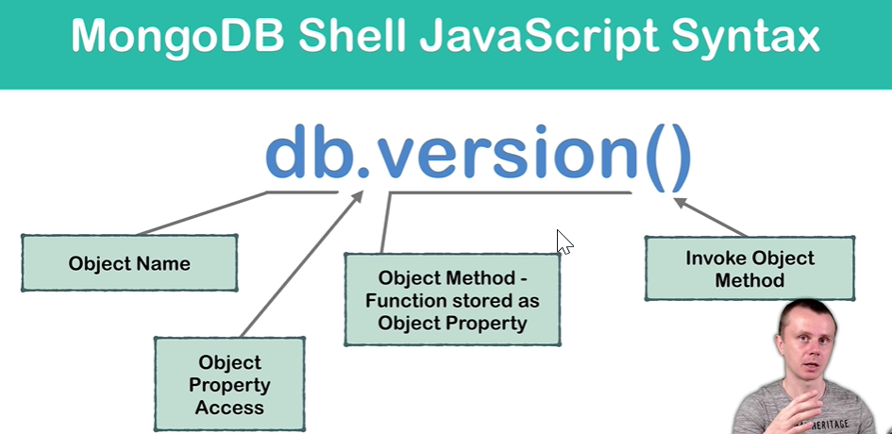
3. 
4. 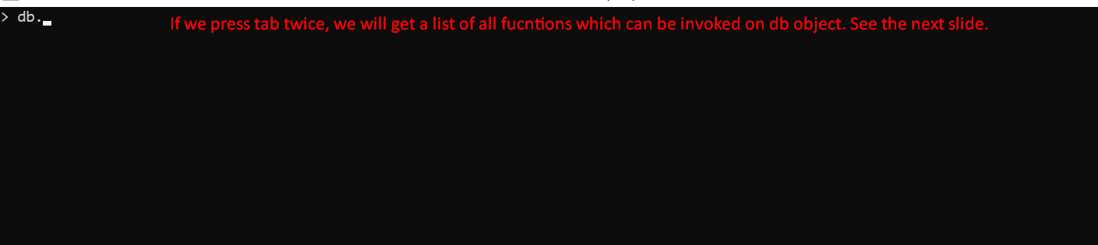
5. 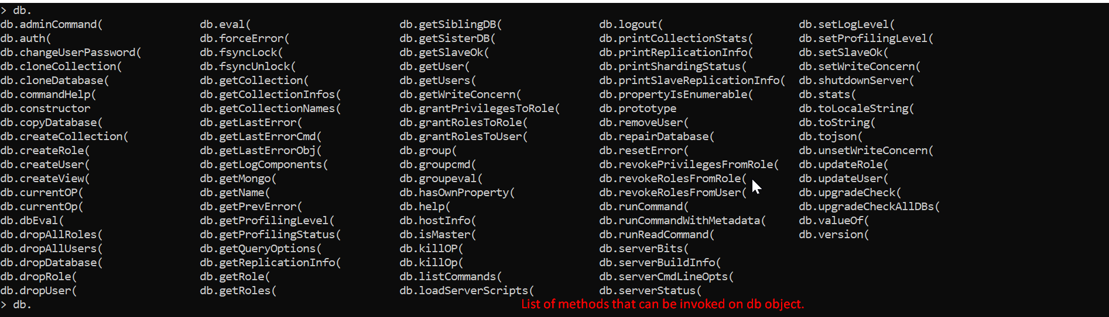
6. 